**Institute of Computer Technology**

**Ganpat University**

**(2CSE301) DATABASE MANAGEMENT SYSTEM**

**Practical 8 MySQL Views (2)**

**Database and tables:**

[**https://drive.google.com/file/d/12ukAhPUqcms9dobK_XKLQgamMO9vVCn0/vie w?usp=sharing**](https://drive.google.com/file/d/12ukAhPUqcms9dobK_XKLQgamMO9vVCn0/view?usp=sharing)

1. Create a view that contains the addresses (department_name, location_id, street_address, city, state_province, country_name) of all the departments

CREATE VIEW department_addresses AS

SELECT

d.DEPARTMENT_NAME,

l.LOCATION_ID,

l.STREET_ADDRESS,

l.CITY,

l.STATE_PROVINCE,

c.COUNTRY_NAME

FROM

departments d

JOIN locations l ON d.LOCATION_ID = l.LOCATION_ID

JOIN countries c ON l.COUNTRY_ID = c.COUNTRY_ID;

select * from department_addresses;

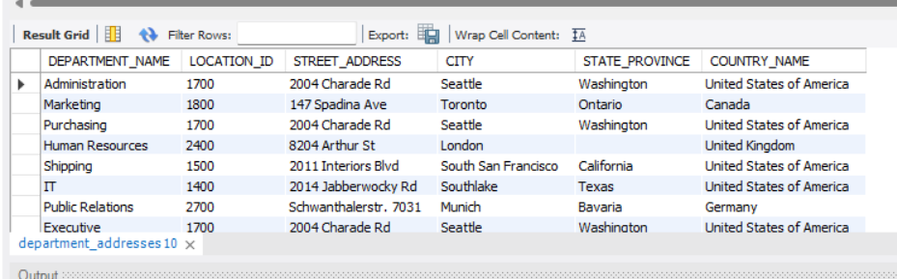

1. Create a view that contains the full name (e.g. Steven King) of all employees along with the country in which they are working

CREATE VIEW employee_country_names AS

SELECT

CONCAT(e.FIRST_NAME, ' ', e.LAST_NAME) AS full_name,

c.COUNTRY_NAME

FROM

employees e

JOIN departments d ON e.DEPARTMENT_ID= d.DEPARTMENT_ID

JOIN locations l ON d.LOCATION_ID = l.LOCATION_ID

JOIN countries c ON l.COUNTRY_ID = c.COUNTRY_ID;

select * from employee_country_names;

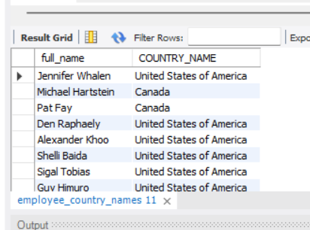

1. Create a view to find the name (first_name, last_name) and salary of the employees whose salary is greater than the average salary.

CREATE VIEW high_salary_employees AS

SELECT

FIRST_NAME,

LAST_NAME,

SALARY

FROM

employees

WHERE

SALARY > (SELECT AVG(SALARY) FROM employees);

select * from high_salary_employees;

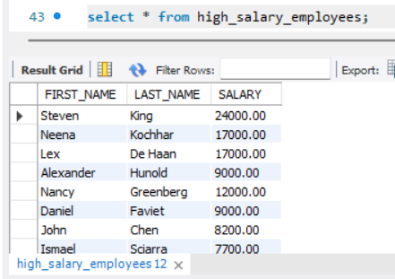

1. Create a view to get the job_ID, JOB_title and maximum salary of the employees where the maximum salary is greater than or equal to $4000.

CREATE VIEW high_salary_jobs AS

SELECT

j.JOB_ID,

j.JOB_TITLE,

MAX(e.SALARY) AS max_SALARY

FROM

employees e

JOIN jobs j ON e.JOB_ID = j.JOB_ID

GROUP BY

j.JOB_ID, j.JOB_TITLE

HAVING

MAX(e.SALARY) >= 4000;

select * from high_salary_jobs;

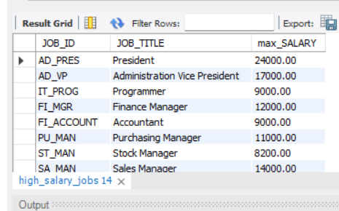

1. Create a view that displays the first_name and last_name of employees who are managers.

CREATE VIEW manager_names AS

SELECT

e.FIRST_NAME,

e.LAST_NAME

FROM

employees e

WHERE

e.EMPLOYEE_ID IN (SELECT DISTINCT MANAGER_ID FROM employees);

select * from manager_names ;

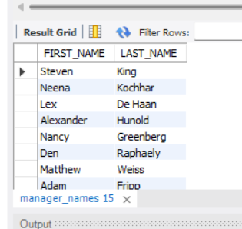

1. Create a view to list the department ID, department_name and city of all the departments where no employee is working.

CREATE VIEW departments_with_no_employees AS

SELECT

d.DEPARTMENT_ID,

d.DEPARTMENT_NAME,

l.CITY

FROM

departments d

JOIN locations l ON d.LOCATION_ID = l.LOCATION_ID

LEFT JOIN

employees e ON d.DEPARTMENT_ID = e.DEPARTMENT_ID

WHERE

e.EMPLOYEE_ID IS NULL;

select * from departments_with_no_employees;

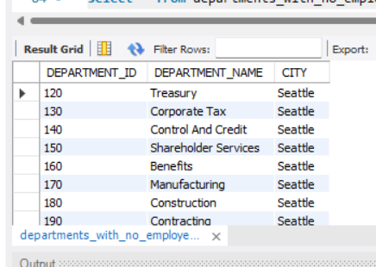

1. Create a view to list the full names and hire_date of the employees who were hired before Susan Mavris.

CREATE VIEW employees_hired_before_susan AS

SELECT

CONCAT(FIRST_NAME, ' ', LAST_NAME) AS full_name,HIRE_DATE

FROM

employees

WHERE

HIRE_DATE < (SELECT HIRE_DATE FROM employees WHERE FIRST_NAME = 'Susan' AND LAST_NAME = 'Mavris');

select * from employees_hired_before_susan;

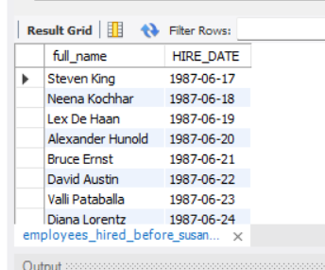

1. Create a view to find the employee ID, job title, number of days between ending date and starting date for all jobs in department 80 and 90.

CREATE VIEW job_duration_view AS

SELECT

e.EMPLOYEE_ID,

j.JOB_TITLE,

DATEDIFF(jh.END_DATE, jh.START_DATE) AS duration_days

FROM

employees e

JOIN job_history jh ON e.EMPLOYEE_ID = jh.EMPLOYEE_ID

JOIN jobs j ON jh.JOB_ID = j.JOB_ID

WHERE

e.DEPARTMENT_ID IN (80, 90);

select * from job_duration_view;

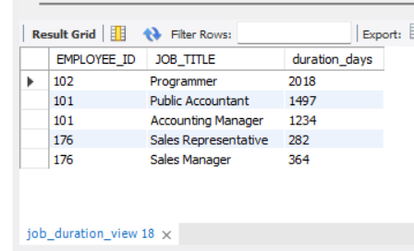

1. Create a view to display the department names in which the difference between minimum and maximum salary is more than 4000

CREATE VIEW departments_salary_difference AS

SELECT

d.DEPARTMENT_NAME

FROM

departments d

JOIN employees e ON d.DEPARTMENT_ID = e.DEPARTMENT_ID

GROUP BY

d.DEPARTMENT_NAME

HAVING

MAX(e.SALARY) - MIN(e.SALARY) > 4000;

select * from departments_salary_difference;

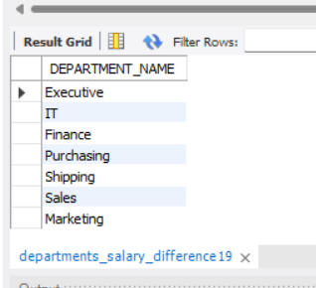

**10.**For all above created views, Update at least 1 record from each and verify whether the update gets reflected in the base table(s) or not

UPDATE high_salary_employees

SET SALARY = SALARY + 1000

WHERE FIRST_NAME = 'John' AND LAST_NAME = 'Doe';

